API TESTING WITH POSTMAN

INTRODUCTION
The Flipkart Products API is a RESTful web service designed to manage product information such as product name, price, availability (stock), and category. This API enables CRUD operations including Create, Read, Update, and Delete on product data stored in a MockAPI backend. The purpose of this mini-project is to test and validate API functionality using Postman tool.
MockAPI acts as a temporary database for development and testing, allowing us to simulate real-time API behavior without requiring a physical server. Postman is used to send HTTP requests and automate validation using test scripts under the Tests tab. This project demonstrates the core principles of REST API testing by implementing HTTP methods such as GET, POST, PUT, PATCH, DELETE, and HEAD.

API Overview & Architecture 1. Introduction to the API
The Inventory Management API is a RESTful service designed to handle basic inventory operations such as product creation, retrieval, updating, and deletion. It enables users to manage product details efficiently through standardized HTTP methods. The API used in this project is hosted on MockAPI, a platform that simulates real-world API behavior and provides predictable, structured responses ideal for testing.
The API follows REST principles, using resource-based URLs, structured JSON responses, and stateless communication. This makes it highly scalable, testable, and compatible with various clients including web applications, command-line tools, and automated testing frameworks such as Postman and Newman.

2. Base URL
The Inventory Management API is accessible using the following base URL:
https://692ab9037615a15ff24d790a.mockapi.io
3. Main API Endpoint The core resource managed in this project is Products. Endpoint: /Products
Field | Type | Description
ProductID | String | Unique identifier for each product
ProductName | String | Name of the product
Suppliers | String | Supplier or vendor name
Stocks | Boolean | Product stock status (true/false)

4.CRUD Operations Overview

a. GET /Products – Retrieve All Products
This endpoint fetches a complete list of products from the inventory. Used for:
- Validating product lists
- Visualizing stock distribution
- Verifying data structure

b. POST /Products – Add a New Product
Allows adding a new product to the database.
{
"ProductName": "Laptop",
"Suppliers": "Tech World", "Stocks": true
}

c. GET /Products/{ProductID} – Retrieve Product by ID
Fetches detailed information about a single product. Used to:
- Verify specific product data
- Validate schema
- Display product card in visualizer

d. PUT /Products/{ProductID} – Update Product
Updates a product’s name, supplier, or stock status.

e. DELETE /Products/{ProductID} – Delete Product
Removes a product from the inventory.
Also includes a follow-up request to verify deletion.

5. Environment Variables Used
To make the collection flexible and reusable, the following environment variables are implemented:

  Variable
  baseURL
  endpoint
  ProductID
  ID
  ProductName
  Suppliers
  Stocks
  Description
  Main API URL
  API resource name ("Products")
  Dynamic ID used for GET/PUT/DELETE
  Separate ID for delete testing
  Dynamic product name
  Supplier name
  Boolean stock value

6.API Architecture

a. RESTful Architecture
The API follows a REST-based architecture, which includes:
- Client–Server Model:
The client (Postman/Newman) sends requests, and the server (MockAPI) returns JSON responses.
- Stateless Communication:
Each API request is independent and contains all required information.
- Uniform Resource Identifiers (URIs):
Resources are accessed using structured endpoints such as /Products/{id}.
- Standard HTTP Methods:
o GET → Read o POST → Create o PUT → Update o DELETE → Remove

b. JSON Data Model
Data flows through the API in JSON format, enabling easy validation and parsing.
Example response:
{
"ProductName": "Keyboard",
"Suppliers": "Digital Store",
"Stocks": true,
"ProductID": "45"
}

c. MockAPI Backend Simulation MockAPI provides:
- Auto-generated IDs
- Cloud-hosted database
- Realistic request/response patterns
- Consistent structure for automated testing
This creates an environment closely resembling a real-world API backend.

7. System Diagram
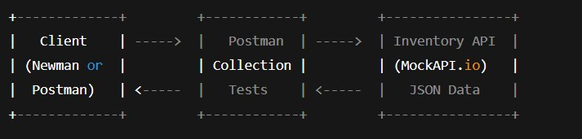

8. Newman and HTML Extra Reporter
Newman is the command-line tool for running Postman collections without using the Postman application. It enables automated execution of API tests directly through the terminal, making it ideal for CI/CD pipelines and repeated testing workflows. Developers can run collections, apply environments, and export results with simple commands like:
newman run Inventory_management.postman_collection.json newman run Inventory_management.postman_collection.json -d data.csv newman run Inventory_management.postman_collection.json -d data.csv -r htmlextra

9.ScreenShots
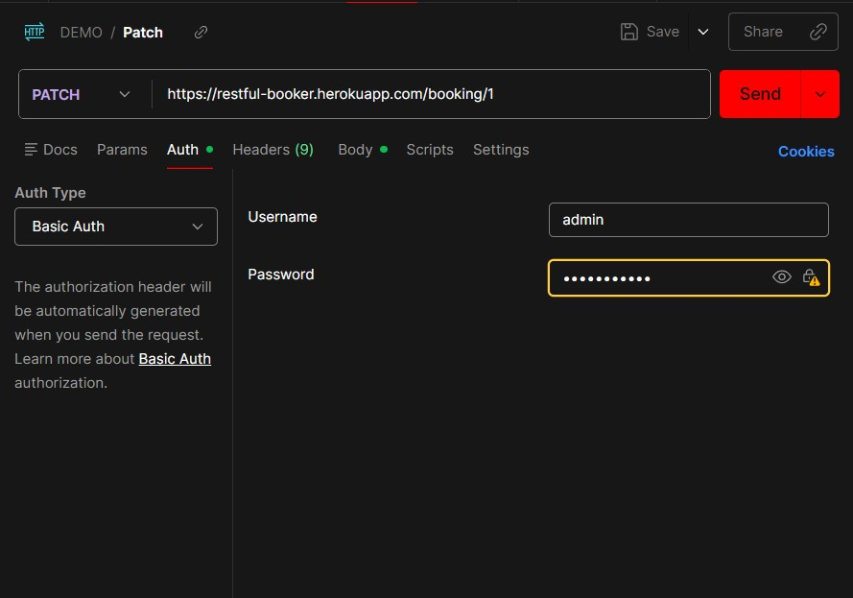

BASIC AUTH
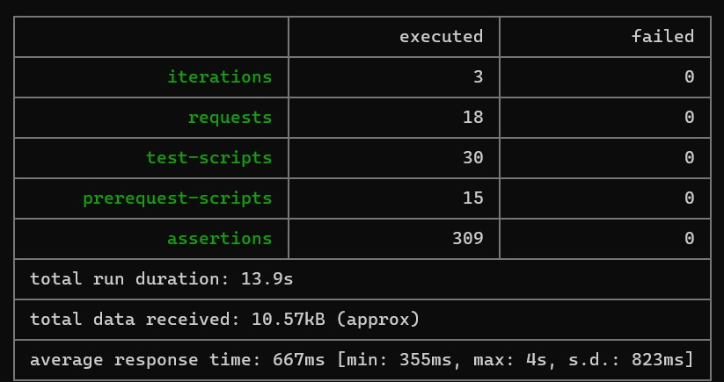

NEWMAN RUN USING CSV

NEWMAN RUN USING JSON

10.CONCLUSION
The Inventory Management API project successfully demonstrates how RESTful services can be tested, validated, and automated using Postman and Newman. Through the use of a structured Postman collection, detailed test scripts, environment variables, and visualizers, the project provides a complete end-to-end approach to API testing. The integration of Newman and the HTML Extra reporter adds automation capabilities and generates professional-quality reports, making the solution suitable for real-world development and CI/CD pipelines. Overall, this project enhances the reliability of API workflows, improves test coverage, and showcases effective tools for modern API testing and documentation.

